Part A — Practice Programs (Hour 1)
Work these in your lab-NN/ folder before the project: do the first one or two in the lab; the
last (For Advanced Learners) is for home.
1. Thread-pool runner: with a fixed pool of 3 (ExecutorService), submit about 10 Runnable
tasks that print their id and sleep briefly; shut down and await completion, observing the
few threads being reused.

import java.util.concurrent.ExecutorService;
import java.util.concurrent.Executors;
import java.util.concurrent.TimeUnit;

class ThreadPoolRunner {
public static void main(String[] args) throws InterruptedException {
ExecutorService pool = Executors.newFixedThreadPool(3);

for (int i = 1; i <= 10; i++) {
int id = i;

pool.submit(() -> {
System.out.println("Task " + id + " running on "
+ Thread.currentThread().getName());

try {
Thread.sleep(500);
} catch (InterruptedException e) {
Thread.currentThread().interrupt();
}
});
}

pool.shutdown();
pool.awaitTermination(1, TimeUnit.MINUTES);

System.out.println("All tasks completed.");
}
}
Output:
First time: Second:
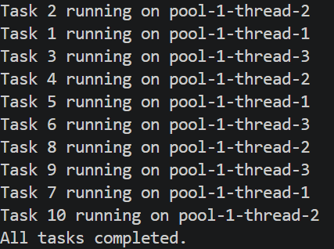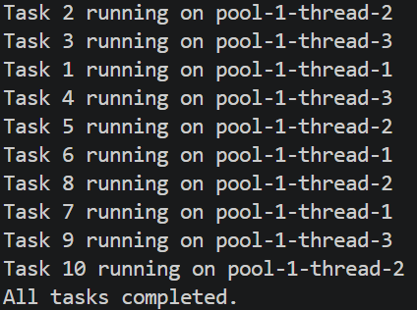

2. Producer–consumer: one thread adds numbers to a small shared buffer and another
removes them, coordinated with wait()/notify(); produce and consume a fixed number of
items in order with none lost.
import java.util.LinkedList;
import java.util.Queue;

class ProducerConsumer {
static Queue<Integer> buffer = new LinkedList<>();
static int size = 3;

static synchronized void produce(int value)
throws InterruptedException {
while (buffer.size() == size) {
ProducerConsumer.class.wait();
}

buffer.add(value);
System.out.println("Produced: " + value);

ProducerConsumer.class.notify();
}

static synchronized int consume()
throws InterruptedException {
while (buffer.isEmpty()) {
ProducerConsumer.class.wait();
}

int value = buffer.remove();
System.out.println("Consumed: " + value);

ProducerConsumer.class.notify();
return value;
}

public static void main(String[] args) throws InterruptedException {
Thread producer = new Thread(() -> {
try {
for (int i = 1; i <= 10; i++) {
produce(i);
}
} catch (InterruptedException e) {
Thread.currentThread().interrupt();
}
});

Thread consumer = new Thread(() -> {
try {
for (int i = 1; i <= 10; i++) {
consume();
}
} catch (InterruptedException e) {
Thread.currentThread().interrupt();
}
});

producer.start();
consumer.start();

producer.join();
consumer.join();

System.out.println("All items produced and consumed.");
}
}

Output:
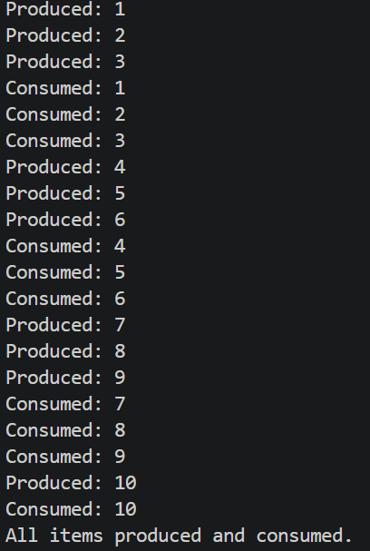

Key Questions / Analysis / Interpretation :
1. Why is a thread pool better than creating a new thread per task?
A thread pool reuses existing threads, reduces thread-creation overhead and manages concurrent tasks more efficiently.
2. How do wait() and notify() coordinate two threads?
wait() makes a thread release the monitor lock and wait. notify() wakes one thread waiting on the same object's monitor so it can compete to continue execution.
3. What causes a deadlock, and how does consistent lock ordering prevent it?
A deadlock occurs when threads wait indefinitely for locks held by each other. In MiniBank, always locking the account with the smaller account number first prevents opposite lock ordering and helps avoid this deadlock.

